Asia-China-Coin-Wang Mang-H 9.2-Mould

weight:166g

size : leight 7.5 cm*width 7.5cm

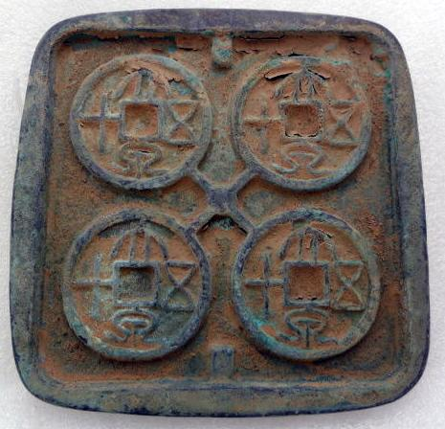

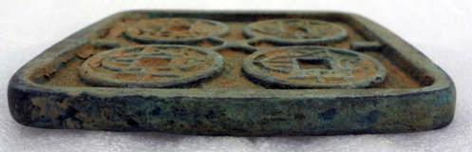

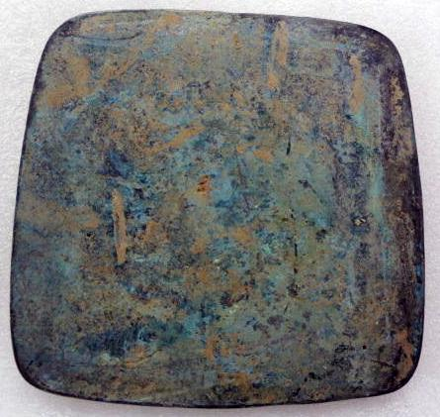

Order details Printer friendly page

Sold by

[cnrelics](http://myworld.ebay.com/cnrelics) ( [18](http://feedback.ebay.com/ws/eBayISAPI.dll?ViewFeedback&userid=cnrelics)  )

+ Show additional actions

Delivery package 1 of 1

Estimated delivery Thursday, Jan 16, 2014 - Thursday, Feb 13, 2014

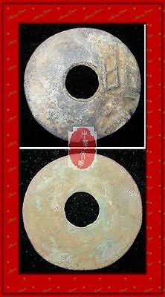

[WarringStatesPeriod ZHAO NATION MINT SEAL LIN MONEY BRONZE ROUND COIN蔺圜钱1.2"RARE](http://www.ebay.com/itm/151193915562)

Item price

$49.99

Quantity

1

Item number

151193915562

Shipping service

Economy Shipping from outside US

[Leave feedback](http://feedback.ebay.com/ws/eBayISAPI.dll?LeaveFeedbackShow&useridfrom=802-867&useridto=cnrelics&item=151193915562&transactid=0) [Contact seller](http://contact.ebay.com/ws/eBayISAPI.dll?FindAnswers&frm=3998&iid=151193915562&redirect=0&requested=cnrelics) [Return item](http://return.ebay.com/ws/eBayISAPI.dll?ResolveReturn&eventName=viewSelectedItem&TransactionId=0&ItemId=151193915562)

Sold by

[lengxue](http://myworld.ebay.com/lengxue) ( [27](http://feedback.ebay.com/ws/eBayISAPI.dll?ViewFeedback&userid=lengxue)  )

+ Show additional actions

Delivery package 1 of 1

Estimated delivery Wednesday, Jan 8, 2014 - Thursday, Jan 16, 2014

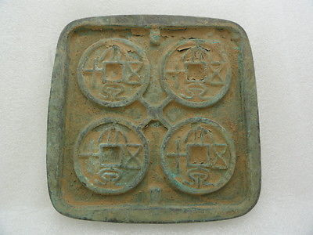

[Oriental Asian Chinese bronze pattern tools of the trade round mould,classical](http://www.ebay.com/itm/141151465238)

Item price

$9.99

Quantity

1

Item number

141151465238

Shipping service

ePacket delivery from China

[Leave feedback](http://feedback.ebay.com/ws/eBayISAPI.dll?LeaveFeedbackShow&useridfrom=802-867&useridto=lengxue&item=141151465238&transactid=905408453004) [Contact seller](http://contact.ebay.com/ws/eBayISAPI.dll?FindAnswers&frm=3998&iid=141151465238&redirect=0&requested=lengxue) [Return item](http://return.ebay.com/ws/eBayISAPI.dll?ResolveReturn&eventName=viewSelectedItem&TransactionId=905408453004&ItemId=141151465238)

Sold by

[bcculture](http://myworld.ebay.com/bcculture) ( [79](http://feedback.ebay.com/ws/eBayISAPI.dll?ViewFeedback&userid=bcculture)  )

+ Show additional actions

Delivery package 1 of 1

Estimated delivery Thursday, Jan 16, 2014 - Thursday, Feb 13, 2014

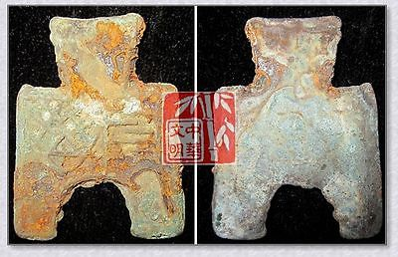

[VINTAGEWarringStatesPeriod WEI NATION CITY MINT MONEY BRONZE SPADE COIN阴晋桥足布1.5"](http://www.ebay.com/itm/251408435322)

Item price

$9.99

Quantity

1

Item number

251408435322

Shipping service

Economy Shipping from outside US

[Leave feedback](http://feedback.ebay.com/ws/eBayISAPI.dll?LeaveFeedbackShow&useridfrom=802-867&useridto=bcculture&item=251408435322&transactid=0) [Contact seller](http://contact.ebay.com/ws/eBayISAPI.dll?FindAnswers&frm=3998&iid=251408435322&redirect=0&requested=bcculture) [Return item](http://return.ebay.com/ws/eBayISAPI.dll?ResolveReturn&eventName=viewSelectedItem&TransactionId=0&ItemId=251408435322)

Sold by

[lengxue](http://myworld.ebay.com/lengxue) ( [27](http://feedback.ebay.com/ws/eBayISAPI.dll?ViewFeedback&userid=lengxue)  )

+ Show additional actions

Delivery package 1 of 1

Estimated delivery Wednesday, Jan 8, 2014 - Thursday, Jan 16, 2014

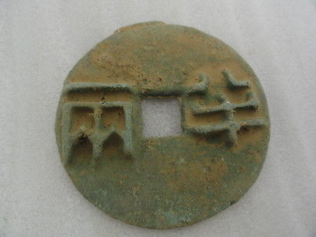

[Chinese bronze pattern tools of the trade Qin DY,sculpture,classical Round,rusty](http://www.ebay.com/itm/141151172510)

Item price

$10.99

Quantity

1

Item number

141151172510

Shipping service

ePacket delivery from China

[Leave feedback](http://feedback.ebay.com/ws/eBayISAPI.dll?LeaveFeedbackShow&useridfrom=802-867&useridto=lengxue&item=141151172510&transactid=905363203004) [Contact seller](http://contact.ebay.com/ws/eBayISAPI.dll?FindAnswers&frm=3998&iid=141151172510&redirect=0&requested=lengxue) [Return item](http://return.ebay.com/ws/eBayISAPI.dll?ResolveReturn&eventName=viewSelectedItem&TransactionId=905363203004&ItemId=141151172510)

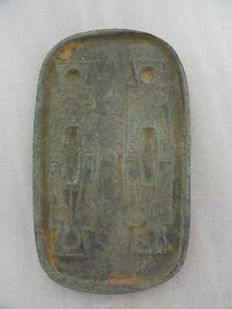

[Oriental Asian Chinese bronze pattern Trading tools trousers mould,classical old](http://www.ebay.com/itm/141151175241)

Item price

$18.00

Quantity

1

Item number

141151175241

Shipping service

ePacket delivery from China

[Leave feedback](http://feedback.ebay.com/ws/eBayISAPI.dll?LeaveFeedbackShow&useridfrom=802-867&useridto=lengxue&item=141151175241&transactid=905360219004) [Contact seller](http://contact.ebay.com/ws/eBayISAPI.dll?FindAnswers&frm=3998&iid=141151175241&redirect=0&requested=lengxue) [Return item](http://return.ebay.com/ws/eBayISAPI.dll?ResolveReturn&eventName=viewSelectedItem&TransactionId=905360219004&ItemId=141151175241)

### Order total

Subtotal $98.96

Shipping $30.00

#### Total

## $128.96

[View PayPal transaction](http://payments.ebay.com/ws1/eBayISAPI.dll?IntermediateResolutionInfo&itemid=151193915562&transId=0&pn=UnifiedCheckoutSummaryRedirect2PP&qs=itemid%3D151193915562%26transId%3D0%26buyerorseller%3D0%26)

### Order information

Order placed on  
Saturday, Dec 28, 2013

Having a problem with this purchase?  
[Resolve problem](http://res.ebay.com/ws/eBayISAPI.dll?ResolutionCenter)

Payment method   
PayPal

Payment date  
Saturday, Dec 28, 2013